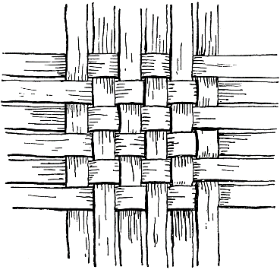
Assembly Mennonite Church
October 27, 2019
Ephesians Bible Study: Woven Together in Christ

Gathering
Welcome and Call to worship

Praising and adoring God
SS 39 Will you come and follow me
Could it be that God is singing (on reverse)
Peace Lamp
L: In Christ the whole building is joined together and rises to become a holy temple in our God.
P: We too are being built together to become a dwelling in which God lives by the Spirit.

Offering ourselves and our gifts
SS 55 Love the Lord your God
Jeremiah 31:31-34
Matthew 24:1-2

Hearing God's word
Children’s time- letters from sister churches
Ephesians 2:11-23**
Sermon “From Bricks and Mortar to Flesh and Blood”
Following the sermon: children singing in room 7 at North end of the building

Responding to the Word
HWB 540 Strong, righteous man of Galilee

Licensing for Pastor Scott Coulter
Doug: Who presents Scott for installation?
Congregation: We, the people of Assembly Mennonite Church, present Scott Coulter. Believing that we have been guided by the Spirit of God, we have called him to be our minister.
Doug: In commending him for this ministry, will you also uphold him in your prayers and with your support?
Cong: Yes. We will stand by him and pray for him.

Sharing our Joys and Concerns
Pastoral Prayer

Sending
Introduction of visitors
Announcements
HWB 407 We are people of God’s peace
Benediction Ephesians 3:20-21

Participants: Worship leader/Children’s Time: Anna Yoder Schlabach, Song leader: Lydia Miller, Peace Lamp/Pastoral Prayer: Lora Nafziger, Scripture reader: Philipp Gollner, Wesley Mast, Lena Osborne; Preacher: Doug Luginbill, Conference Minister, Visuals: Kajsa Herrstrom.

