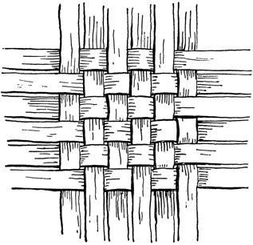
Assembly Mennonite Church
October 20, 2019
Fall Bible Study: Ephesians

Gathering
Welcome
Call to worship (drawn from 3:14-19)
This we ask of our Creator, who loves all beings: That the Spirit strengthens our inner selves with the fullness of glory. That we may lead lives reflective of Christ because of our faith. That our rootedness in Love continue to reveal that immense, knowledge-exceeding love, along with our fellow believers. And that we be filled to the brim with the boundless presence of God.
Opening Song – STJ 27 God of the Bible

Adoring and Confessing
Song – STJ 35 O Breath of Life
Peace Lamp – Systemic brokenness
L: In Christ the whole building is joined together and rises to become a holy temple in our God.
P: We too are being built together to become a dwelling in which God lives by the Spirit.
Song of Response - STJ 65 Let justice flow like streams

Offering ourselves and our gifts
Offering Song – STJ 17 Halle, halle, hallelujah!

Hearing God's word
Children’s time - letters from sister churches
Scripture: chapter 2: 1-10
Sermon

Responding to the Word
Song of Community - STJ 72 One is the body
Sharing our Joys and Concerns
Pastoral Prayer

Sending
Introduction of visitors
Announcements
Benediction (drawn from 3:20-21)
To God, whose power- now at work in us, can do immeasurably more than we ask or imagine-- to God be glory in the Church and in Christ Jesus through all generations, world without end. Amen
Sending song – STJ 74 Now go in peace

Serving in worship today:
Worship leader - Jonathon Schramm, Song leader – Jeanne Leichty, Peace lamp – Karl Shelly, Children’s time – Scott Coulter, Scripture reader – Kathy Meyer Reimer, Preacher – Regina Shands Stoltzfus, Pastoral prayer – Scott Coulter

2nd Hour Elective options:
Ephesians- Join each Sunday's preacher for further discussion and exploration of the Ephesians text. Worship Space
Departing Consumer Culture is based on the book An Other Culture, and discusses some of the questions of finances, ethics, just living and ecology raised in our recent stewardship of money series. North end of the multipurpose (MP) space, East side.
Asking the Big Questions Join a pastor to discuss this week's question: "How do we engage the Bible faithfully when we've moved beyond a literalistic reading?" North end of the MP space, West side.
Contemplative space- We have designated Room 14 to be space for quiet prayer, reflection and sitting. Please enter and leave in silence.

